ContactManagement_Verify Contact notes _Instance44_13-Jul-2018_04-18-25_AM_Validatingcontactentitynavigation.png

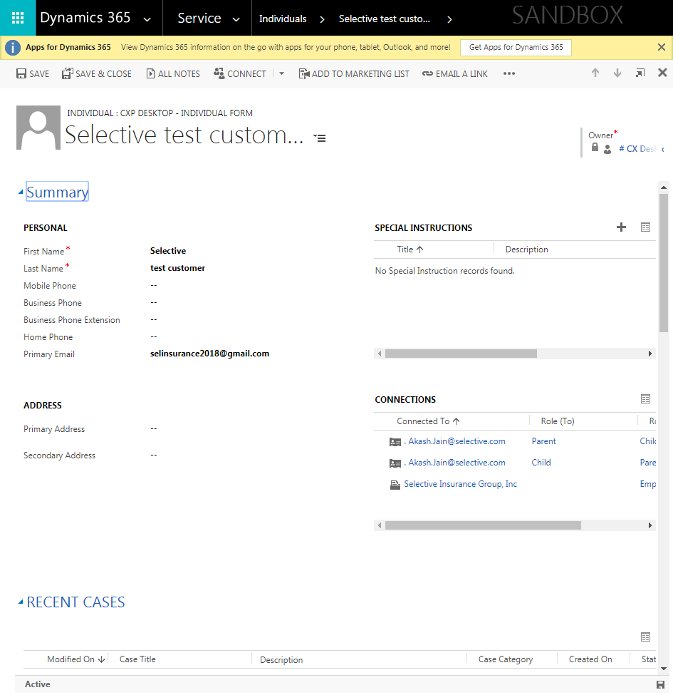

ContactManagement_Verify Contact notes _Instance44_13-Jul-2018_04-16-12_AM_MouseClickActiononStaleElement.png

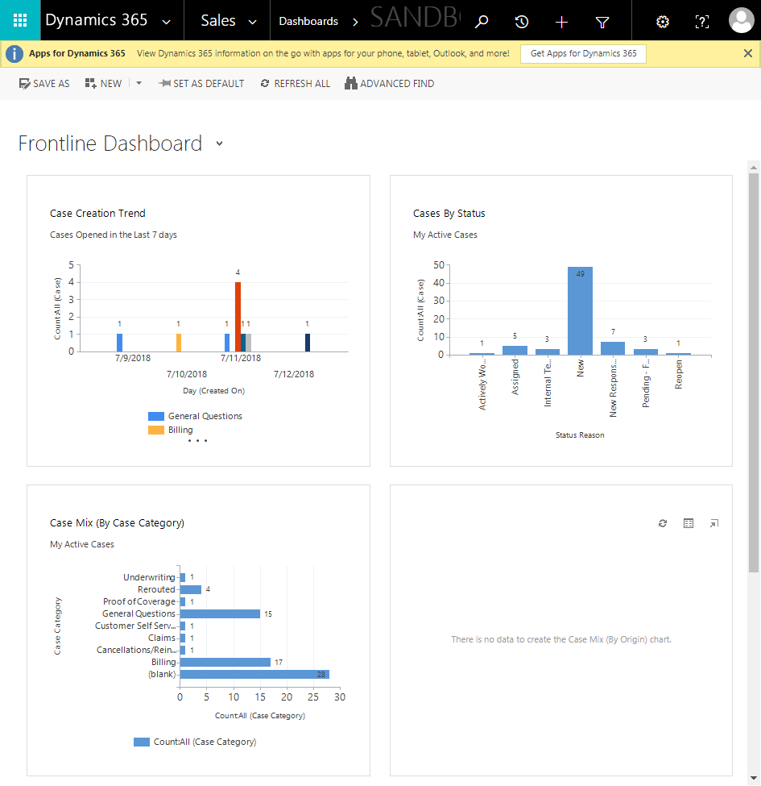

ContactManagement_Verify Contact notes _Instance44_13-Jul-2018_04-07-12_AM_VerifyingAllNotesofanindividual.png

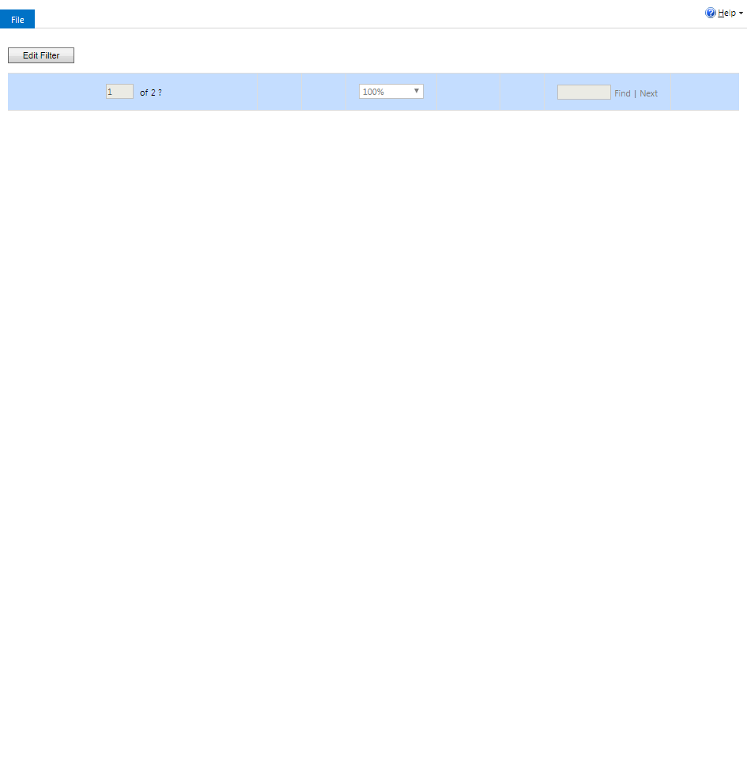

ContactManagement_Verify Contact notes _Instance44_13-Jul-2018_04-12-52_AM_VerifyingLatestNotesofanindividual.png

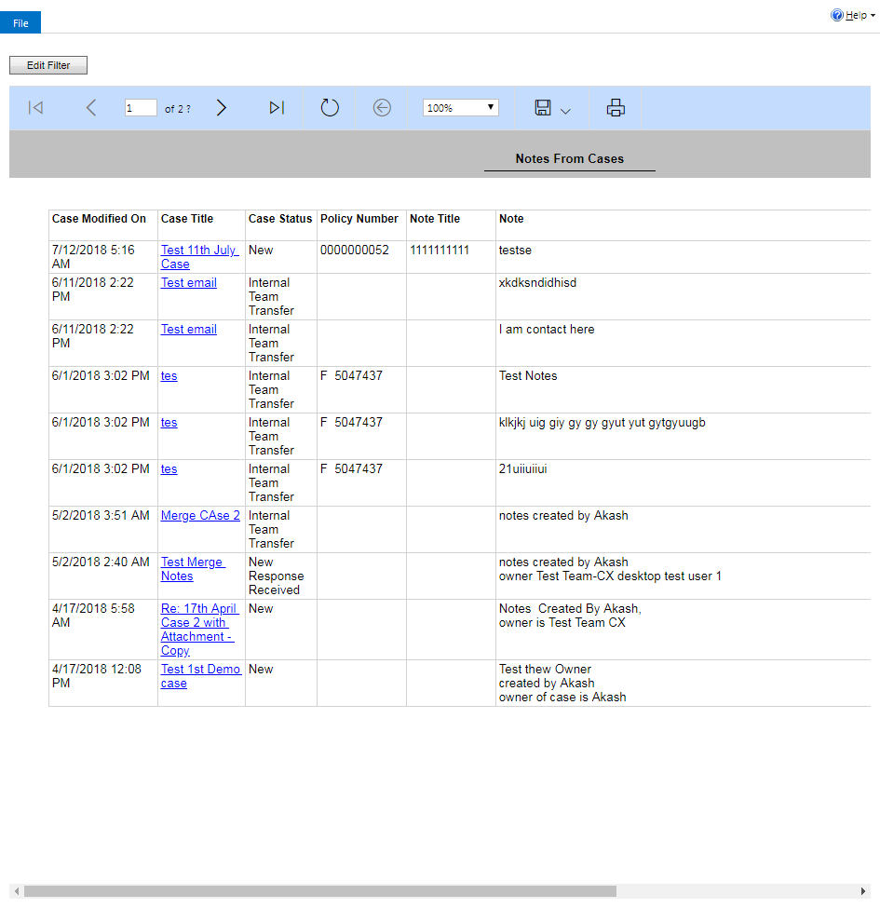

ContactManagement_Verify Contact notes _Instance44_13-Jul-2018_04-12-54_AM_VerifyingAllNotesofanindividual.png



ContactManagement_Verify Contact notes _Instance44_13-Jul-2018_04-07-03_AM_Validatingcontactentitynavigation.png

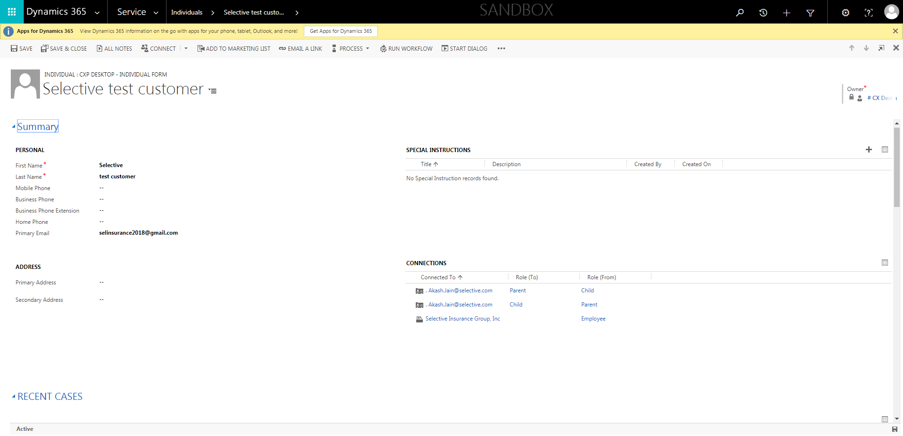

ContactManagement_Verify Contact notes _Instance44_13-Jul-2018_04-05-53_AM_SingleSignOn.png

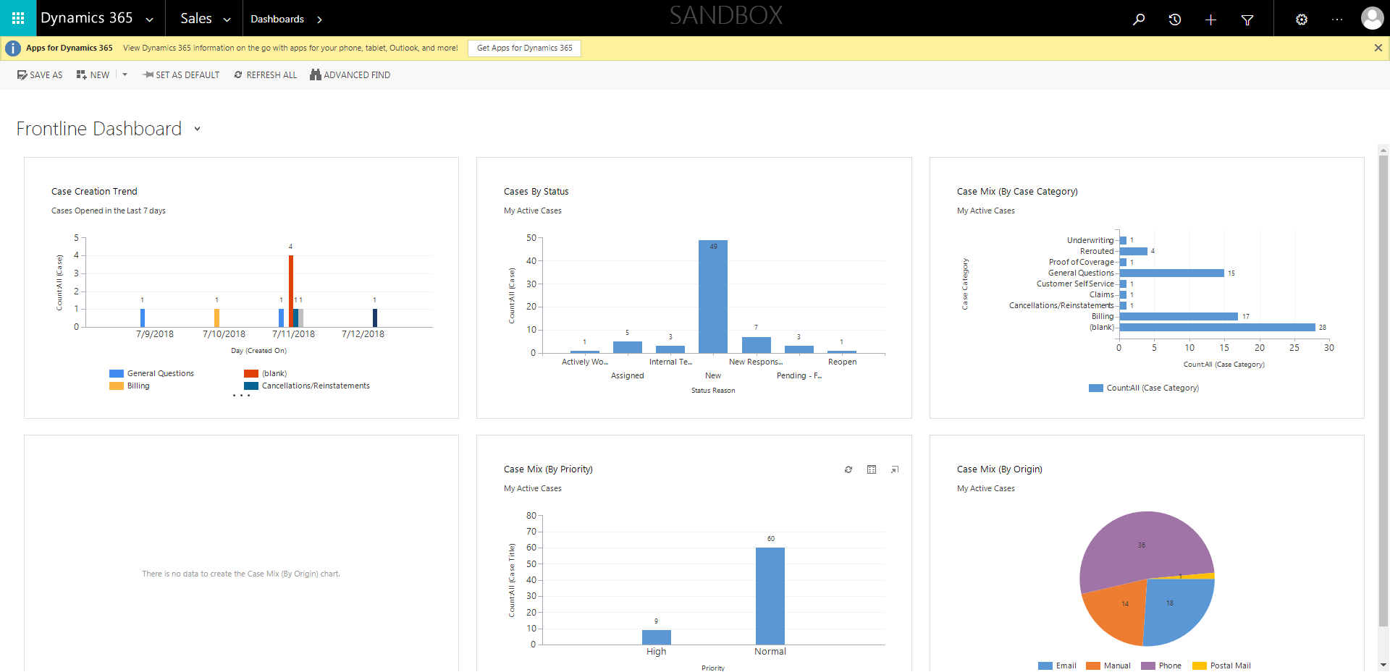

ContactManagement_Verify Contact notes _Instance44_13-Jul-2018_04-05-31_AM_MouseClickActiononStaleElement.png

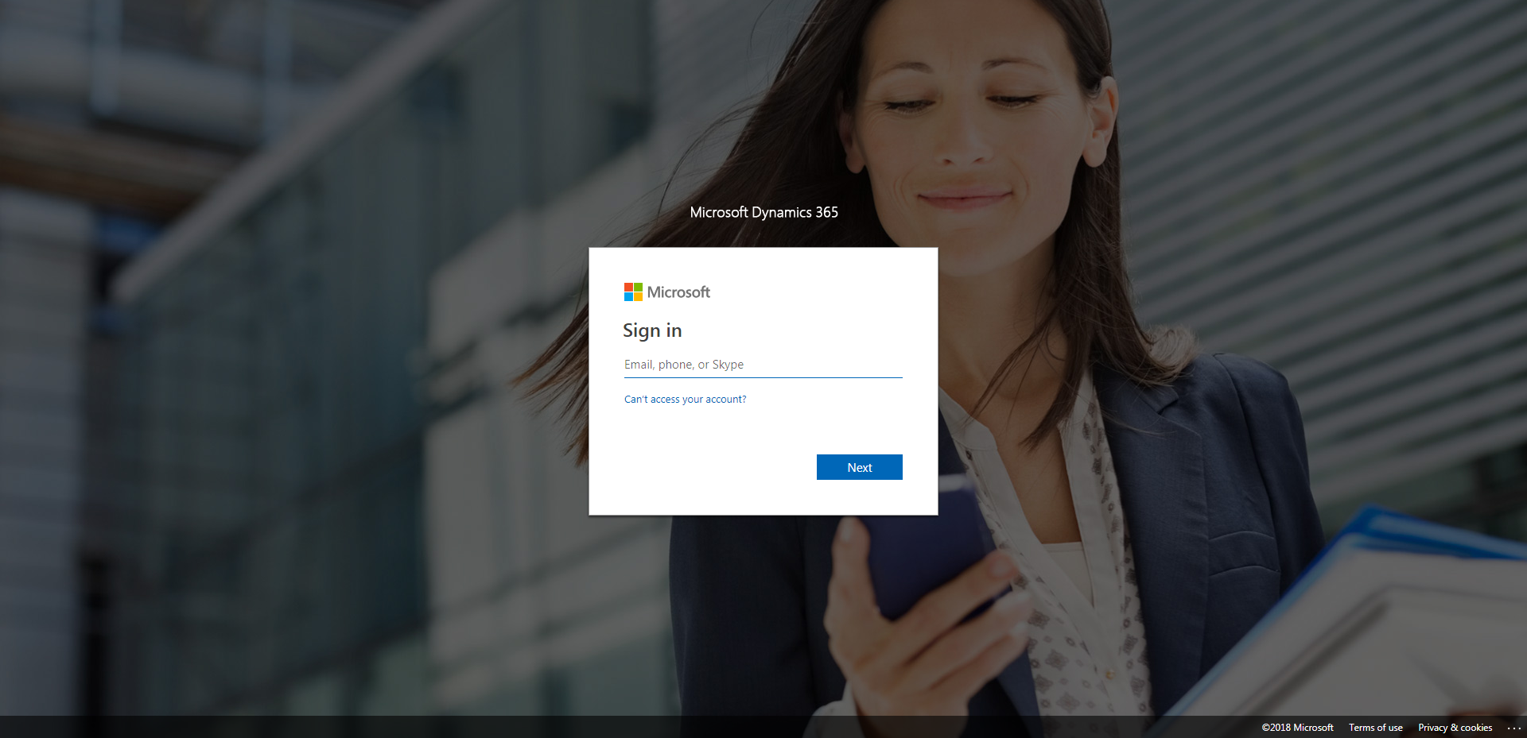

ContactManagement_Verify Contact notes _Instance44_13-Jul-2018_04-05-34_AM_MouseClickActiononStaleElement.png

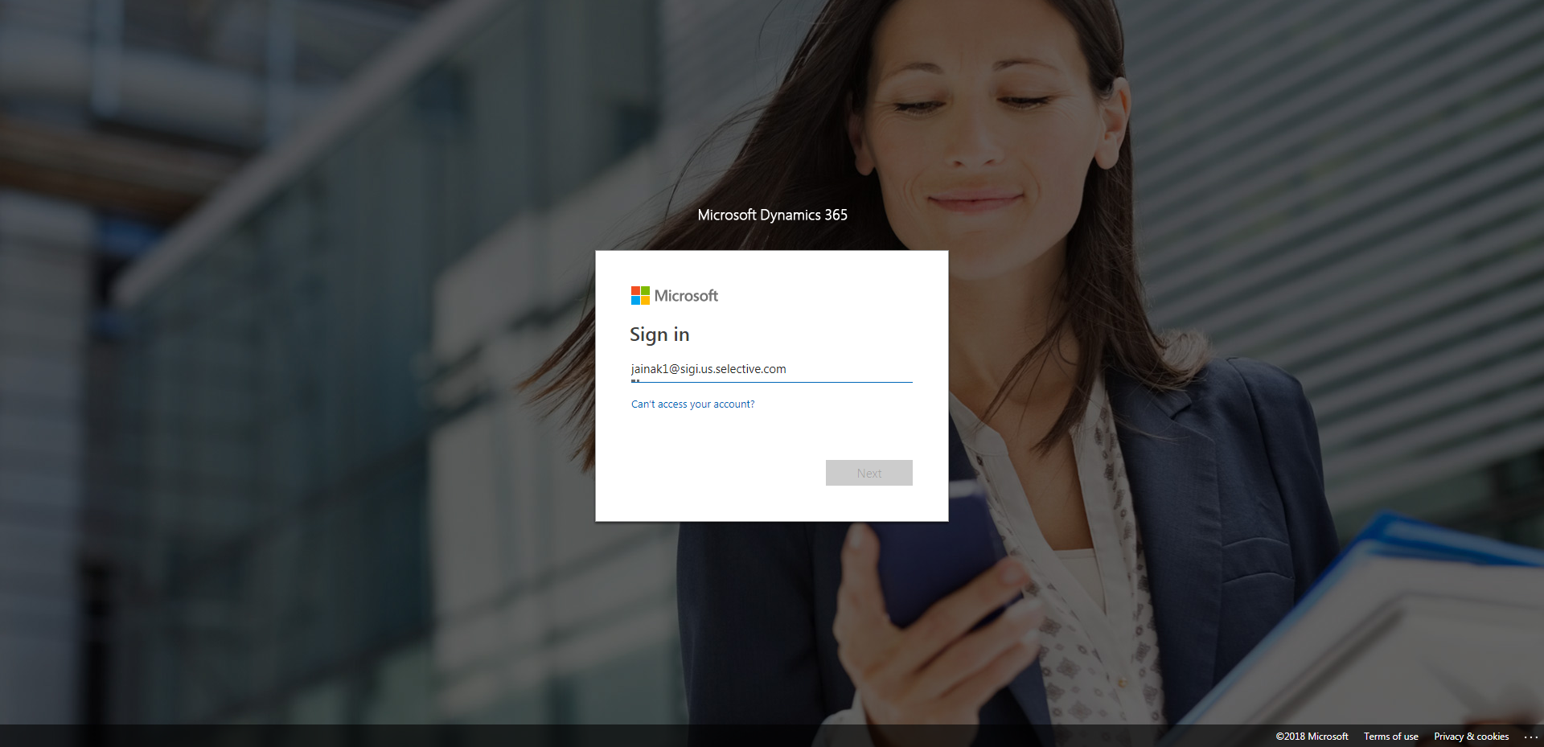

ContactManagement_Verify Contact notes _Instance44_13-Jul-2018_04-16-12_AM_SingleSignOn.png



ContactManagement_Verify Contact notes _Instance44_13-Jul-2018_04-10-31_AM_SingleSignOn.png

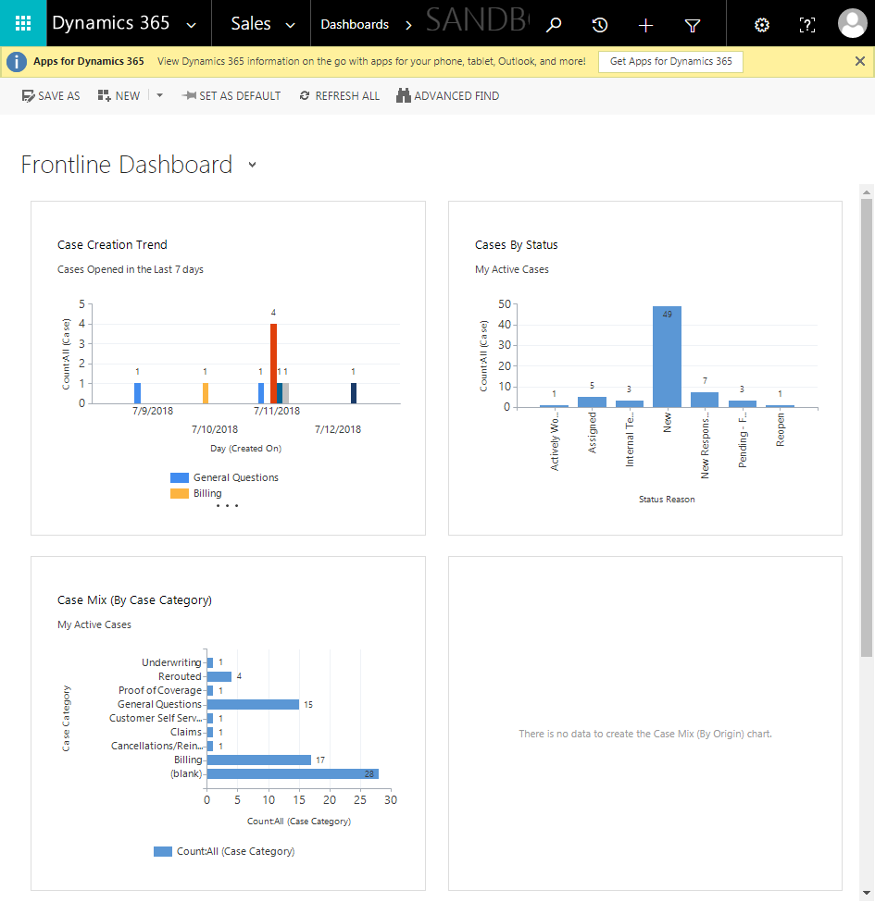

ContactManagement_Verify Contact notes _Instance44_13-Jul-2018_04-05-32_AM_EnterTextAction.png

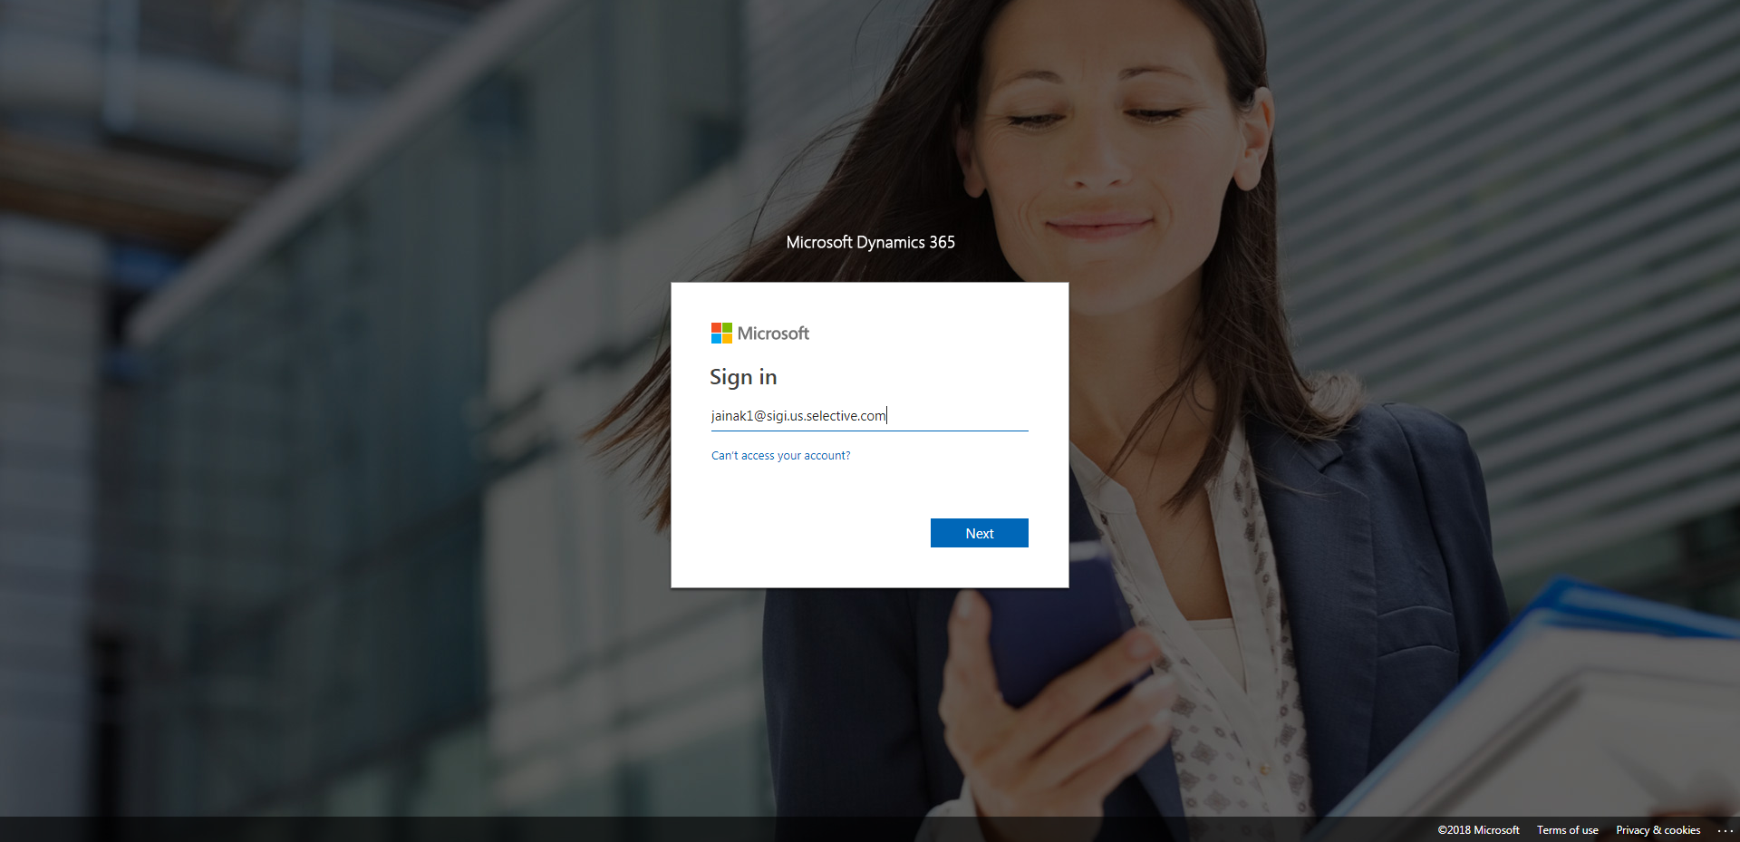

ContactManagement_Verify Contact notes _Instance44_13-Jul-2018_04-09-48_AM_EnterTextAction.png



ContactManagement_Verify Contact notes _Instance44_13-Jul-2018_04-05-49_AM_SingleSignOn.png

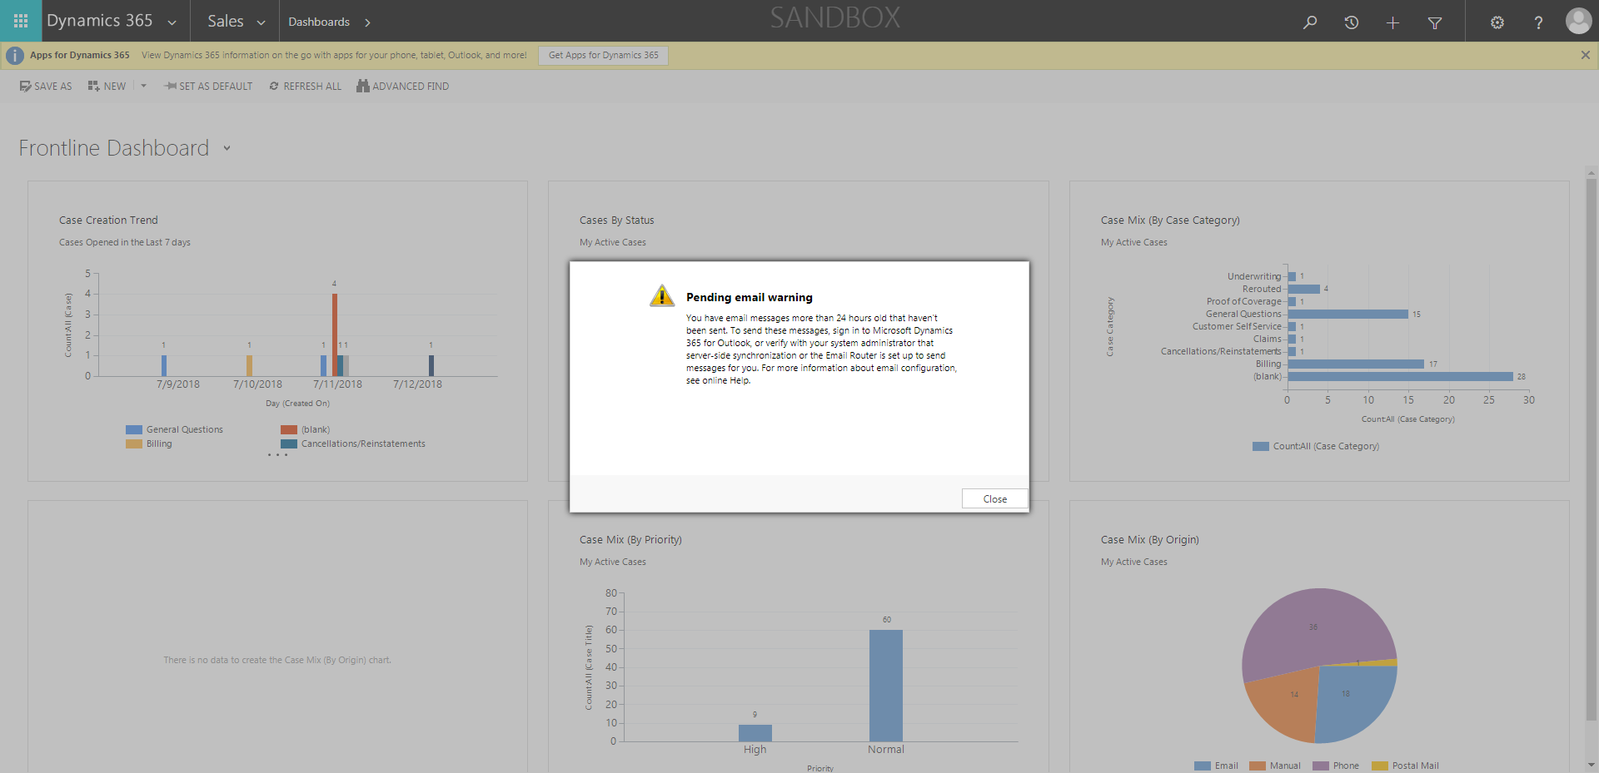

ContactManagement_Verify Contact notes _Instance44_13-Jul-2018_04-18-32_AM_VerifyingAllNotesofanindividual.png



ContactManagement_Verify Contact notes _Instance44_13-Jul-2018_04-14-47_AM_MouseClickActiononStaleElement.png



ContactManagement_Verify Contact notes _Instance44_13-Jul-2018_04-10-30_AM_MouseClickActiononStaleElement.png



ContactManagement_Verify Contact notes _Instance44_13-Jul-2018_04-09-05_AM_MouseClickActiononStaleElement.png

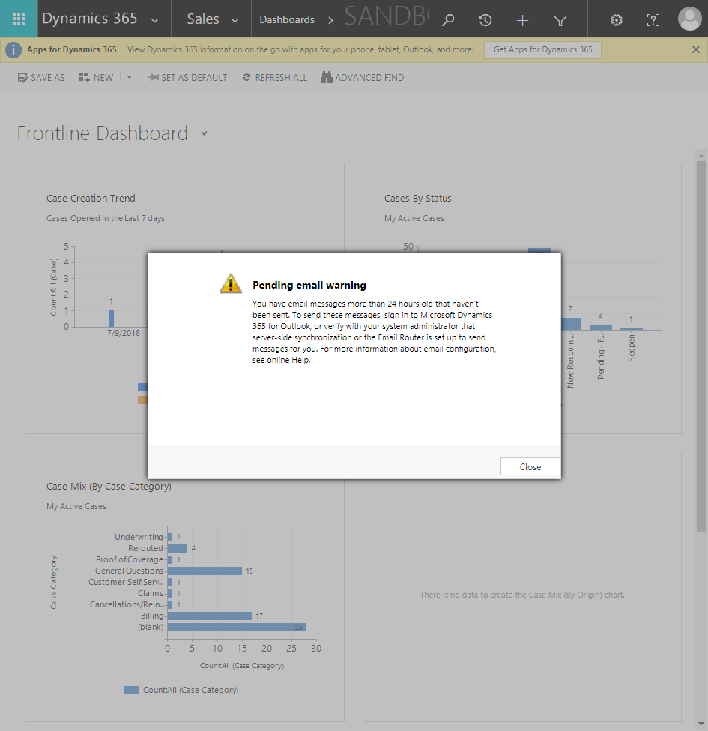

ContactManagement_Verify Contact notes _Instance44_13-Jul-2018_04-15-29_AM_EnterTextAction.png



ContactManagement_Verify Contact notes _Instance44_13-Jul-2018_04-12-46_AM_Validatingcontactentitynavigation.png



ContactManagement_Verify Contact notes _Instance44_13-Jul-2018_04-18-30_AM_VerifyingLatestNotesofanindividual.png

